|  |  |
| --- | --- |
| **Logo_FPT_University_doc** | **MINISTRY OF EDUCATION AND TRAINING** |

|  |
| --- |
| **FPT UNIVERSITY** |
| Software User’s Manual |
| OATS |
|  |
| |  |  | | --- | --- | | **Group** | | | **Group Members** | Huynh Minh Tu – Team leader –  An Ngoc Anh – Team member – 60223  Bui Tuong Thi – Team member – 00721  Nguyen Duc Tan – Team member - | | **Supervisor** | Mr. Nguyen Huy Hung | | **Ext Supervisor** |  | | **Capstone Project code** | OATS | |
|  |

Ho Chi Minh City, 08/2013

**Record of Changes**

|  |  |  |  |  |
| --- | --- | --- | --- | --- |
| **Date** | **Changed Item** | **Description** | **By** | **Version** |
| 07/08/2013 | All | Create Document | AnhAN | 0.1 |
|  |  |  |  |  |
|  |  |  |  |  |
|  |  |  |  |  |
|  |  |  |  |  |
|  |  |  |  |  |
|  |  |  |  |  |
|  |  |  |  |  |

# **Installation Guide**

## Setting up the environment at server side

The following software must be installed into the server machine:

#### Hardware requirements:

* Personal computers for developing with the minimum configuration: CPU Core 2 Duo 2.0GHz, 2GB of RAM, 120GB of hard disk, and internet.

#### Software requirements:

* + Operating system: Windows 7
  + Framework: ASP.NET MVC 4.0
  + Microsoft SQL Server 2012: used to create and manage the database for web application

## Deployment at server side

#### Prepare deployment package

* Extract the deployment package toa folder on the server.
* *For exmaple: D:\Capstone Project\SVN*

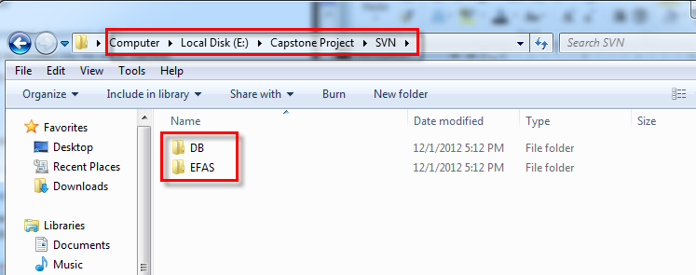

#### Deploy database

* Open Microsoft SQL Server Management Studio
* Create a database named **OATSDB**

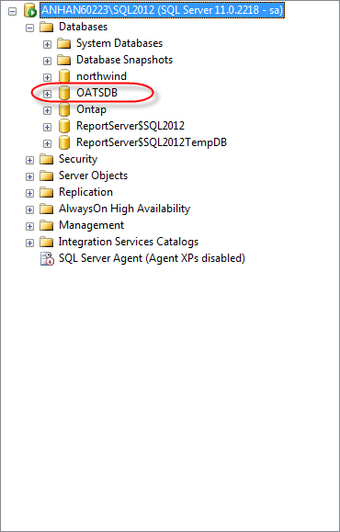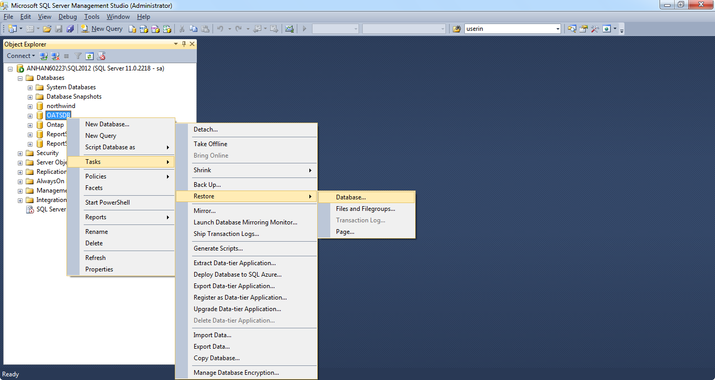

* Right click on the OATSDB database and choose **Tasks -> Restore -> Database…**
* Choose From **device** and clicks … (**3** **dots**) but

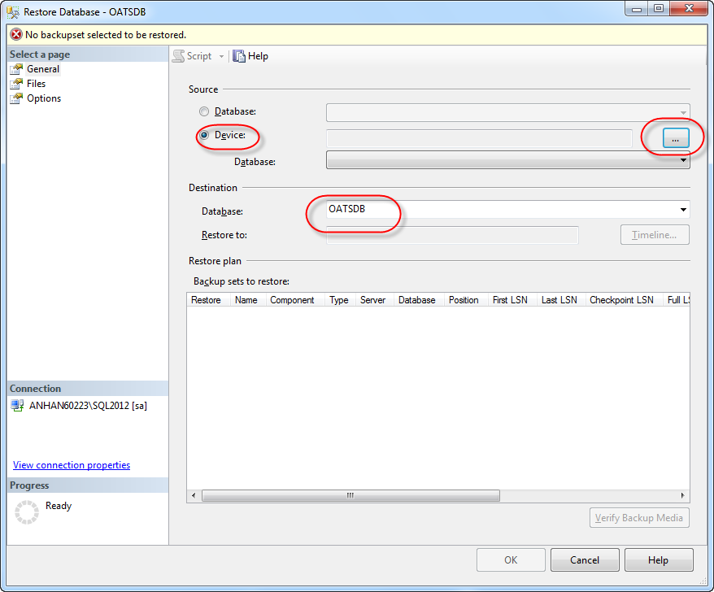

* Click **Add** button

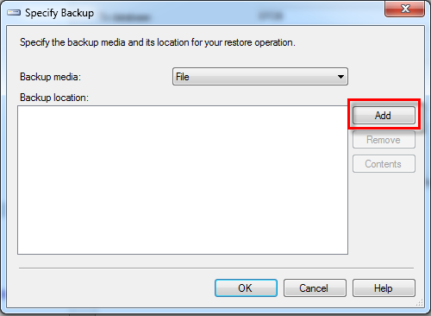

* Browse to **OATSDB\_v0.1** file and click **OK** button **two** times for backing to the Restore Database - OATSDB dialog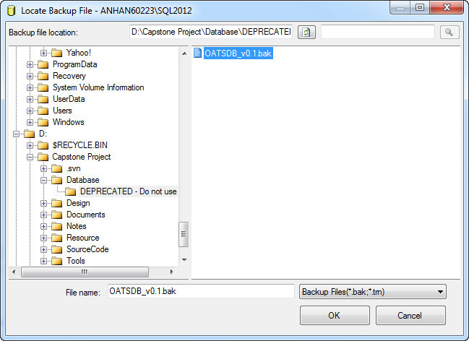
* Check the checkbox in **Restore** column, and then click **Options**

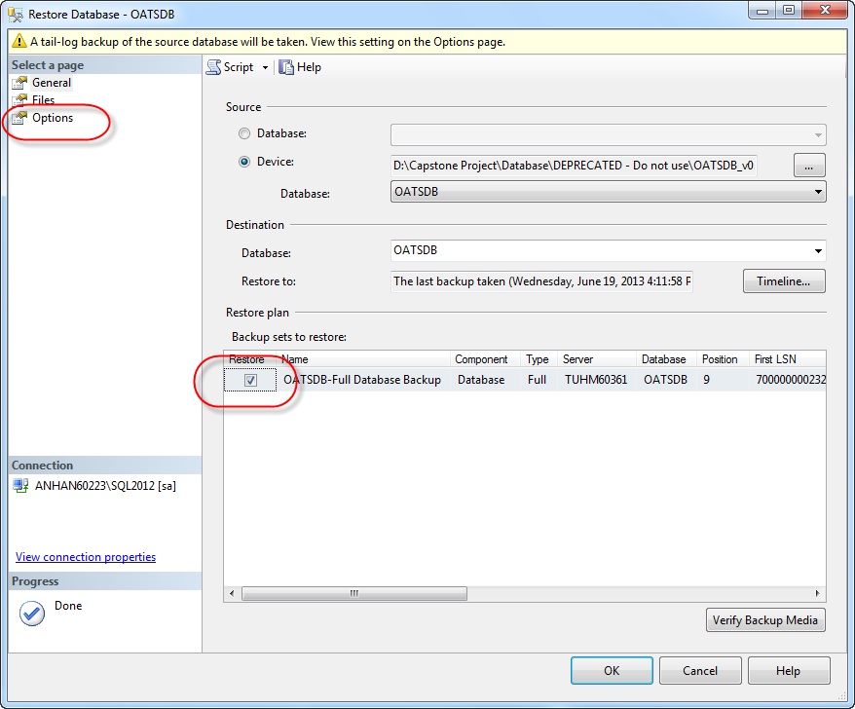

* Check **Overwrite the existing database (WITH REPLACE)** and click **OK** button

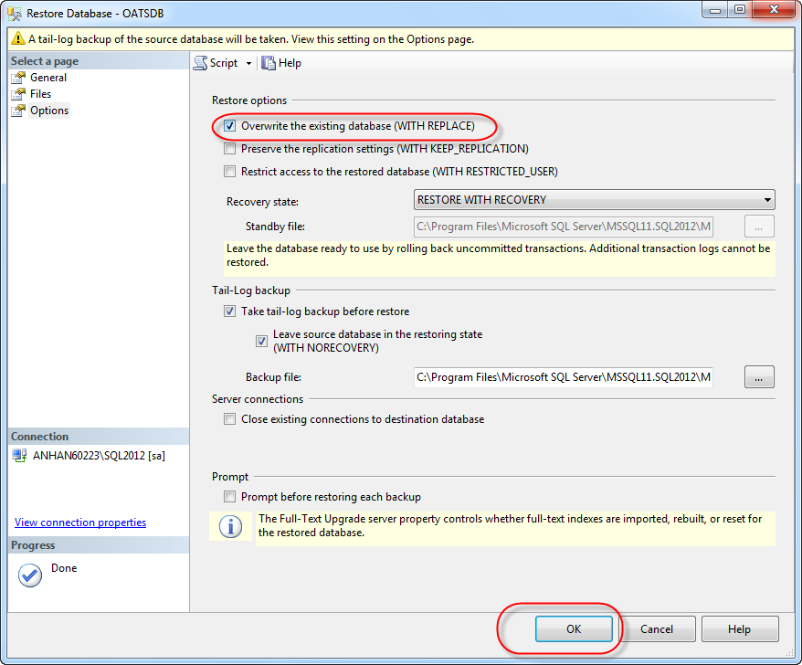

## Setting up the environment at client side

* N/A

# **User‘s Guide**

## Guest’s Guide

### Register

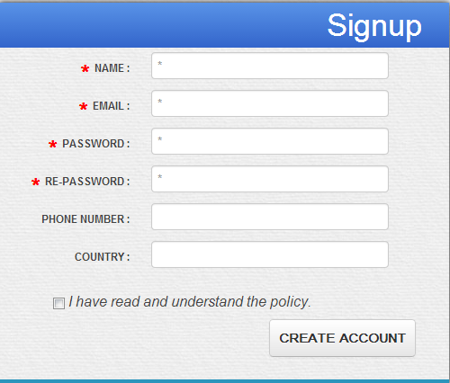

### Login

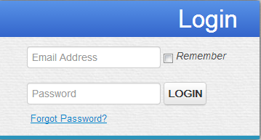

## User’s Guide

## Teacher’s Guide

## Student’s Guide